

Scene and Technical Design Document

Dark Fantasy Armoury 3D Scene



08/05/2025

De montfort university

Sion Scognamillo P2729452

## Index:

Contents

Index: 1

Introduction: 2

Context: 3

Scene Vision: 3

Workflow: 4

Research: 6

Scene Design: 8

Asset List: 9

Modelling: 10

Materials: 12

Lighting 13

Project management 14

Prototype Description: 15

Bibliography: 16

## Introduction:

This dark fantasy armoury project has been inspired by the indie title: Dark and Darker by Ironmace *(figure* ***1,2****),* which for context is a dungeons and dragons influenced PVPVE dungeon crawler extract videogame. I have plenty experience playing Dark and Darker; and to be given an opportunity to improve my development skills, gain marks for my course as well as pay homage to my favourite game, is simply too good to pass up.

Figure **1**,**2** - Ironmace and its IP; Dark and Darker (2022)

This Design Document will cover all technical and design related aspects of the project. The project consists of bringing together three main aspects of the 3D production pipeline: modelling, materials and scene design.

The purpose of limiting the scope of the project to these three areas to ensure a high level of polish. These three areas are some of my favourites and I am looking forward to enjoying the project while improving my skills.

Modelling will be the primary and most heavily invested area of the project, as I will be modelling all the props in the scene myself. Specifically hard-surface modelling dark fantasy and medieval inspired props such as archaic weapons, armour, scene props and the environment. *See figures (****3****,****4****,****5****).*

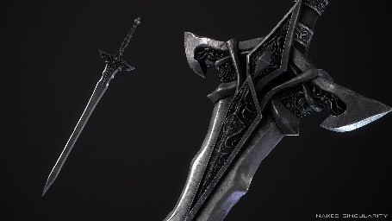

Figures **3,4** and **5** - Examples of weapon, armour and scene props

Materials will be used to add further detail and aesthetics to the models I produce, this is an important step of the pipeline as the materials used can very much make-or-break the visuals of the models and when implemented into the scene, will have a massive effect on the scene in its entirety.

Materials while so crucial to the desired result are also the aspect of the production that I have the least experience in and so will be a vital part of my research required to complete the project.

Scene design will be used to ideate and create this armoury, inform spacing, lighting and structuring decisions.

## Context:

This 3D scene takes place within a dark fantasy game setting, the scene depicts the interior of a smithy and armoury conjoined building with the purpose of storing, creating, providing weapons and armour the protectors of the people around it. *See figures (****6, 7****).*

*Figures* ***6, 7*** *- Example exterior and interior of an armoury building.*

## Scene Vision:

I envision a dark fantasy armoury 3D scene, inspired by real medieval props and weapons, using modern dark fantasy video media reference material to assist in scale, art style and architecture. *See figures (****8,******9****,* ***10****).*

*Figures* ***8****,****9*** *and* ***10*** *– Examples of popular modern dark fantasy videogames*

In this armoury I see a stone block floor and hard wood weapon racks and furniture, I see iron fixtures, an ambient glowing hearth, a forge and a metal workstation. The weapons, stored on the racks, crafted from gleaming metal, with a knight’s functional, decorative plate armour on a stand nearby. *See figures (****11****,****12****,****13****).*

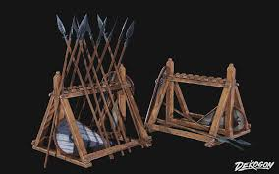

Figures **11**,**12** and **13** - Examples of weapon, armour and scene props

The exterior will not be included in the scene, there will be windows to allow light shafts to enter the room which I intend to use to spotlight key highlights. In part this decision is because it will allow me to concentrate my attention on making the interior as good as possible.

## Workflow:

Once the project had begun and I had decided on this path the first thing to do was to create an initial scene blockout to give visible digital representation to my thoughts. With a challenge ahead I researched as much of the required information, things like modelling techniques and reference materials.

Naturally the next thing to do was begin documenting the process and progress of the project, at the same time I began to design the scene layout, which props I would need and where they would go, or at least an early version of the final product in plan.

Developing models came after planning, the first to be created where building blocks, weapons, tools, chests and more. Key features will be developed slightly later in the pipeline to allow for time to improve my skills.

Creating the next prototype came next to identify problems, solidify the path forward and provide further insight into what will be required. The answer was a series of improvements to my models, optimisation considerations and further development of the scene, assets and documentation.

Retopology and UV unwrapping are next, developing quality textures and decals after to bring the models to life and after which I will be ready to model the main armour highlight piece. Once that is done and textured the only things left to do are assemble the scene a last time and polish it to ensure a quality outcome.

For a full breakdown of the workflow undertaken please see the development log in the bibliography. *See figure (****14****).*

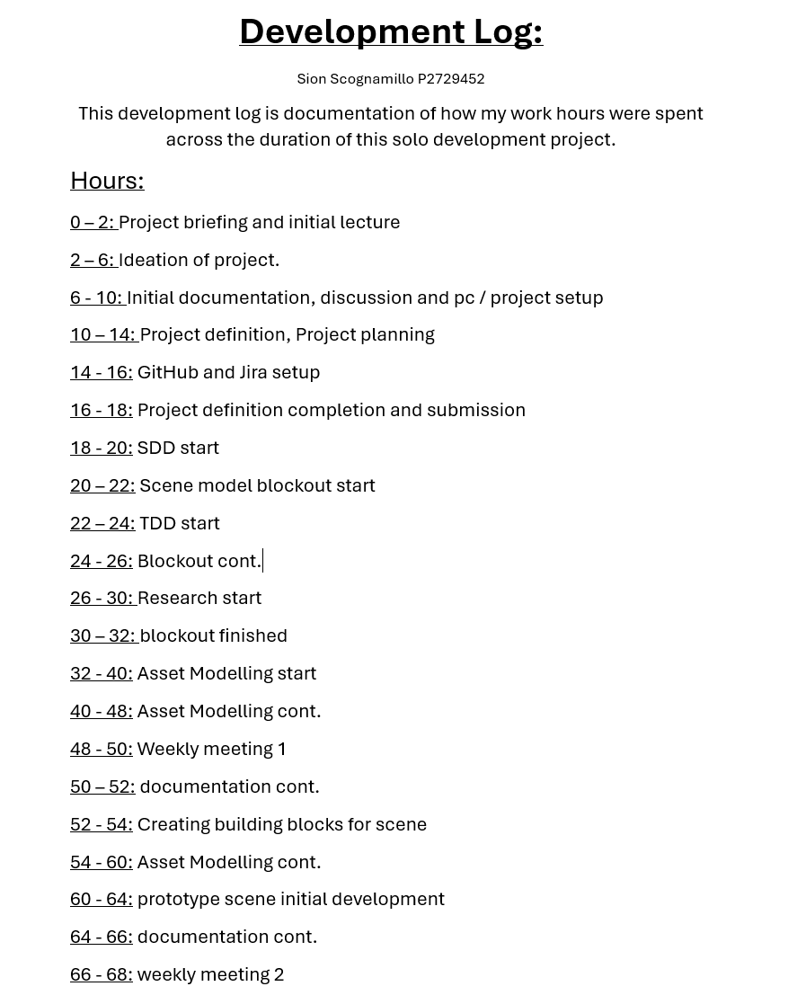

*Figure* ***14*** *– Sample of Development Log.*

## Research:

Research areas include the following topics: advanced 3D hard surface modelling, high quality materials and textures for 3D models, 3D scene design x dark fantasy level design, dark fantasy art / aesthetics style including reference material and finally scene optimisation focused on PC platform.

A selection of lessons learnt, and information gained from my research and practice are below:

Advanced 3D hard surface modelling research:

The book: Blender 3D Incredible Models by Arijan Belec *Figure (****15****)*; contains lots of concise and key information for effective 3D modelling from a foundational level all the way to advanced techniques, it has been a great help to my confidence to have this book reinforce my blender learning curve.

(**16**) How I make armor in Blender by Baril3D; a highly informative YouTube tutorial on modelling a pair of greaves and a chest plate from scratch, extremely relevant for my current goal of making some plate armour, this video will form the basis of my armour creation workflow moving forward.

(**17**) How to Model ANY Sword in Blender! By Vertex Arcade, A YouTube tutorial for the making of 3 different stylized swords, I learnt how to use the screw modifier for making handles from here, which is a helpful tool as it opens a great number of possibilities when it comes to making weapon handles.

(**18**) Power of Wall Factory in Blender 4.2 by 3Dnot2D; A guide on how to set up and use the wall factory add-on in Blender, which I am using to construct the walls and floors of my 3D scene, this saves me time as I don’t need to model the walls myself, the modularity is helpful as well as it allows for customization.

(**19**) Five Topology Tips Every 3D Artist Should Know by DECODED; A simple yet effective lesson in improving topology when modelling which is always a good thing and will assist in optimizing performance, reducing memory drain and freeing up that processing power for other tasks, like texel density.

Materials research:

(**20**) Learn the BASICS of Material Shading in BLENDER (Part 1 + 2) by Brandon 3D; An introduction to basic material setup and creation followed by how to use PBR materials/textures. I intend to use this guide to help me create PBR materials for wood, stone and metal.

(**21**) 3D Environment Design with Blender by Abdeliah Hamdani; A book which teaches about scene design and photorealism, including knowledge like vanishing points, PBR materials and the use of modifiers for optimal results. Utilising the scene design knowledge in this book will result in an improved, more cohesive scene.

Reference materials can be found in the linked mood board in the bibliography. *See figure* ***22****.*

Figure **22** – Sample of mood board.

## Scene Design:

The scenes design from a more technical perspective consists of two main sections, the armoury room and the smithy room which are connected but are on slightly different heights and serve different purposes. While these two rooms are similar, they also require different props to convey the right feeling. (*See figure* ***23****)****.***

Hearth

Sunken Forge Room

Elevated Armoury Room

Chests



forge

anvil



Cabinets



Armour stand



workbench



Table and chairs

Stairs



Entrance

Weapon racks

Figure **23** – Diagram of scene layout.

In the armoury there are the weapon racks, armour stands, chests with a table and chairs next to the hearth, intended as a strong defended structure to store supplies.

In the smithy there is the forge, anvil, grindstone and workbench for crafting the weapons and armour stored adjacent, with tools, trinkets and other crafting ingredients stored on nearby shelves.

The floor and walls are stone block supported by wooden beams with the roof made of wood beams and slate.

## Asset List:

The asset list will contain all the models used in the project, structured well in an excel spreadsheet for ease of access and strong documentation.

See asset list excel spreadsheet in bibliography below. (See figure **24**).

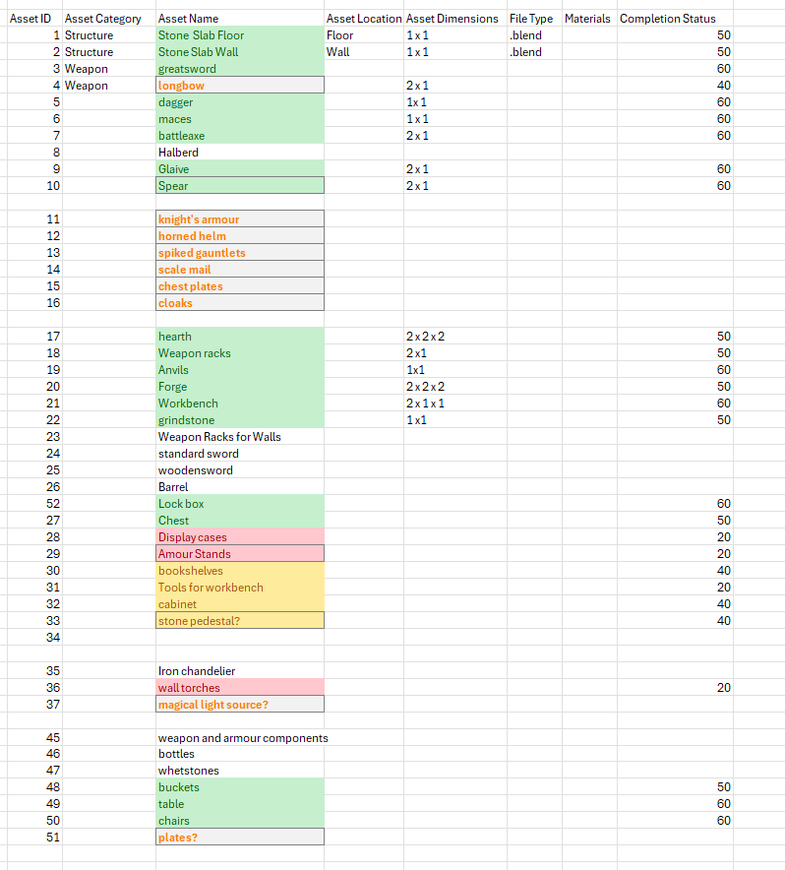

Figure **24** - Sample of asset list.

## Modelling:

To begin with the modelling, I will create a very simple scene blockout, using largely primitive shapes. The purpose of this blockout is to give the scene a digital representation early on so that I can identify areas that need more attention or development as well as use the blockout to help showcase or explain the project.

After the block out is completed, seen below, I moved onto development of assets for the final product, which in this case was first a series of weapons, swords, spears, glaives and other scene props like tables, chairs and chests. *(See figure* ***25****).*

Figure **25 –** Initial scene blockout.

It was during that next phase when I encountered my first modelling problem, while making the spear head below I made a mistake, I had forgotten to axis-lock the plane I was manipulating during one of the early extrusions, and as such it bent the blade which became apparent when the mirrored plane-blade tips didn’t align perfectly with each other. The result is seen in the screenshots below. *(See figure* ***26, 27****).*

Figure **26, 27** – Example modelling errors.

Once the prototype scene below had begun to take form at the end of the next sprint of modelling, I continued developing scene props to fill the scene, as well as proceeding to model the armour and other scene highlights. *(See figure* ***28****).*

Figure **28** – My scene prototype.

The walls and floor in the figure above are created using the wall factory Blender add-on that I learnt about during my research, this provides 2 main benefits, firstly using an add on to create building blocks saves time and the aesthetic of the walls produced by the add on are more than suitable for this project. Secondly the walls produced are also modular, which means I can construct the scene in a way that is completely customizable and expandable.

## Materials:

Materials will be used to elevate the models to the next level, with good use of procedural textures and PBR materials and I am hopeful that the scene props will look excellent.

Focusing on a few main textures, I will be creating a wood texture will a nice grain and adjustable colour for variety as there are lots of wooden props, some of which can be seen in the screenshot above. Furthermore, I will also need a stone texture for the building blocks of the scene as well as a high-quality polished metal texture for the blades of the weapons. Ideally using trim sheets for these grain-based textures to create detailed 3D textures efficiently to save memory.

UV unwrapping in preparation for the materials is a large task with a high number of models and so the plan is to pay special attention to important and highlight features, and use the auto unwrap native to blender on the less important scene props, I will correct any unsuccessful auto unwraps by marking the seams by hand.

I am aiming for high and consistent texel density, likely above a thousand per object with slightly more on the highlight models, with good topology this should be possible. In addition, I will use decals to increase the amount of detail in the scene and to provide variety to models.

A challenge I will soon face will be creating appropriate materials for a functional yet decorative set of combat plate armour, with research and practice I aim to succeed.

## Lighting

**

Figure **29,30** - Examples of good lighting from Elden Ring

I aim to use windows, forge / hearth light and wall torch fixtures, in addition to any further light source creations, in each room to successfully hit all for type of lighting for interior design; ambient, task, accent and decorative.

The plan is to use the forge and hearth in their respective rooms as the ambient / main light source, I will position the sun and windows so that key features are well light, lanterns on the table and crafting bench in their respective rooms will be used as task lighting to emphasize the utility stations.

Wall torches are positioned to provide accent lighting to the surrounding scene props around the outside of the room; I hope to be able to include a magical light source however that is outside the scope of the project currently and a potential future goal. (*See figure* ***23****)****.***

Hearth

Sunken Forge Room

Elevated Armoury Room

Chests



forge

anvil



Cabinets



Armour stand



workbench



Table and chairs

Stairs



Entrance

Weapon racks

Figure **23** – Diagram of scene layout

Project management

Figure **31, 32** – Jira and GitHub logs respectively.

Managing this project so far has been a good learning experience, with the assistance of a supervising professor and tools such as Jira and GitHub to organize and store my project, helping me develop both the project and my personal skill set to be ready to enter the industry.

I am currently on schedule and progressing well certain areas such as modelling, topology and scene prototyping are taking less time than expected which allows me to spend more time on more difficult areas of the project such as the critical armour set modelling and creation of quality materials.

As seen in fig (**31**), my development cycles are a series of weeklong sprints with predetermined goals and backlogs from previous weeks, this AGILE sprint set up allows me to break down the task and time available into individual tasks, combined with the regular GitHub commits in fig (**32**)ensuring safe keeping of the project files and protecting against technical failures, while this is a solo project, these tools are designed to be used by a team for group cohesion and familiarity with the software is a boon.

## Prototype Description:

Project Name: Dark Fantasy Armoury 3D Scene  
Student Name: Sion Scognamillo  
Supervisor: Artur Machura  
(400 words)

1. Project Overview  
Provide a brief introduction to the project. Describe the core idea:

This dark fantasy armoury project has been inspired by the indie title: Dark and Darker by (**1**) Ironmace (2022), which for context is a dungeons and dragons influenced PVPVE dungeon crawler game. I have plenty experience playing Dark and Darker; and to be given an opportunity to improve my development skills, gain marks for my course as well as pay homage to my favourite game, is simply too good to pass up.

2. Core Features  
List the main features of the prototype. Focus on what is implemented in this phase.

This project takes the form of an armoury and smithy joined in the same building in two separate rooms, both rooms contain classic dark fantasy props that fit in each room, armour and weapons, forge and metal work tools etc. The hearth, forge, torches and windows will provide light, likely themed, to the scene to help convey the dark fantasy element.

3. Technical Implementation  
Describe how the prototype is built, including programming techniques,  
frameworks, and tools used.

The prototype was built firstly using Blender to 3D model all the relevant models and props, some of which are listed above, specifically speaking, the blades of the weapons are the most difficult bit of modelling I’ve done so far, using a plane, mirror modifier and references, I shape the plane into a blade, then adding depth to the blade to create the right form. This step is difficult at times, particularly with non-uniform shapes. An example problem I’ve encountered is recorded in the Modelling section of this document.

Once modelled I applied basic blender materials such as colour, roughness and metallic sheen where suitable. Next, I used the Wall Factory add-on in Blender to construct the walls and floors, combining this with the models and applying some level design to create a prototype of the scene.

4. Limitations & Future Development  
Identify any known issues or limitations and propose next steps for future  
iterations.

Looking towards future development, which includes continuing asset development to fully fill out the scene, modelling complex and intricate armour and creating suitable materials and textures for the models as well as implementing lighting to emphasize the themes.

Foreseeable problems and limitations include the difficulty of modelling the armour, the time it will take to create materials and textures as well as using all I’ve created in the best way possible in scene design. To that end, at this time I find it likely that there will be no character in the scene and instead the knight will be displayed as a suit of armour on a stand instead.

## Bibliography:

1. Ironmace 2022 Logo. <https://www.darkanddarker.com/home>
2. Dark and Darker videogame IP.<https://www.darkanddarker.com/home>
3. marketplace dark fantasy weapons used as reference / context material <https://www.unrealengine.com/marketplace/en-US/product/dark-fantasy-weapons-skeletal-mesh-ready> UE
4. Knight in Flowers from Wallpaper Engine.
5. Dreams Time Dark Fantasy forge.
6. Example armoury exterior, imagine AI generated by DeepAi, using a provided prompt. <https://deepai.org/machine-learning-model/text2img>
7. The interior of a Medieval Armoury & Forge by Chris Galloway. <https://www.behance.net/gallery/66923871/Medieval-Armoury-Forge#>
8. Elden Ring poster <https://en.bandainamcoent.eu/elden-ring/elden-ring>
9. Witcher 3 poster <https://www.thewitcher.com/us/en/witcher3>
10. Bloodborne poster <https://www.playstation.com/en-gb/games/bloodborne/>
11. Medieval Weapons rack from artstation.com by Shaafi Ahmad. <https://www.artstation.com/artwork/dOZo3x>
12. Lawbringer character with cosmetics from For Honor by Ubisoft <https://forhonor.fandom.com/wiki/Lawbringer> <https://www.ubisoft.com/en-gb/game/for-honor>
13. Root RPG, image taken from Pinterest by Vernon Meh <https://www.pinterest.com/pin/449585975292020875/>
14. Sample of my personal development log which tracks my hours spent on this project [Development Log.docx](https://demontfortuniversity-my.sharepoint.com/:w:/g/personal/p2729452_my365_dmu_ac_uk/EYp2ZRD-zAFBgP9HPqFPFnQBfe_1QfdR5JxQrZoH7YVgvw?email=artur.machura%40dmu.ac.uk&e=vgnimt)
15. Blender 3D Incredible Models by Arijan Belec; [https://books.google.co.uk/books?hl=en&lr=&id=ieF9EAAAQBAJ&oi=fnd&pg=PP1&dq=advanced+3d+hard+surface+modelling&ots=rOnytD5xdR&sig=xszWXtways0gSXpmHj5Fxa2iZBU&redir_esc=y#v=onepage&q=advanced%203d%20hard%20surface%20modelling&f=falsehttps://books.google.co.uk/books?hl=en&lr=&id=ieF9EAAAQBAJ&oi=fnd&pg=PP1&dq=advanced+3d+hard+surface+modelling&ots=rOnytD5xdR&sig=xszWXtways0gSXpmHj5Fxa2iZBU&redir_esc=y#v=onepage&q=advanced%203d%20hard%20surface%20modelling&f=false](https://books.google.co.uk/books?hl=en&lr=&id=ieF9EAAAQBAJ&oi=fnd&pg=PP1&dq=advanced+3d+hard+surface+modelling&ots=rOnytD5xdR&sig=xszWXtways0gSXpmHj5Fxa2iZBU&redir_esc=y#v=onepage&q=advanced%203d%20hard%20surface%20modelling&f=falsehttps://books.google.co.uk/books?hl=en&lr=&id=ieF9EAAAQBAJ&oi=fnd&pg=PP1&dq=advanced+3d+hard+surface+modelling&ots=rOnytD5xdR&sig=xszWXtways0gSXpmHj5Fxa2iZBU&redir_esc=y)
16. How I make armor in Blender by Baril3D; <https://www.youtube.com/watch?v=JPRuT4X_LAk>
17. How to Model ANY Sword in Blender! By Vertex Arcade; <https://www.youtube.com/watch?v=4BdJGojnHsw>
18. Power of Wall Factory in Blender 4.2 by 3Dnot2D; <https://www.youtube.com/watch?v=9NhLVyhSAic>
19. Five Topology Tips Every 3D Artist Should Know by DECODED; <https://www.youtube.com/watch?v=m8JkR6tI_q4>
20. Learn the BASICS of Material Shading in BLENDER (Part 1 + 2). by Brandon 3D; <https://www.youtube.com/watch?v=Wg244y2f9Fw> <https://www.youtube.com/watch?v=jBT6MD7IzHU>
21. 3D Environment Design with Blender by Abdeliah Hamdani. <https://books.google.co.uk/books?hl=en&lr=&id=XrWqEAAAQBAJ&oi=fnd&pg=PP1&dq=blender+materials&ots=5nKE6GZPF-&sig=tQYkxGK8wh7-HmFjQOWTO1A3UA8&redir_esc=y#v=onepage&q=blender%20materials&f=false>
22. Sample of my mood board contains reference images. <https://www.canva.com/design/DAGk-TOEeJo/pjPMFpgYDgkO8G4uBj9exA/edit?utm_content=DAGk-TOEeJo&utm_campaign=designshare&utm_medium=link2&utm_source=sharebutton>
23. Diagram of the potential final scene layout, made by me in word.
24. Sample of my asset list excel sheet. [Dark Fantasy Armoury 3D Scene (1).xlsx](https://demontfortuniversity-my.sharepoint.com/:x:/g/personal/p2729452_my365_dmu_ac_uk/EUfdhAwDH71Hkb7lY5yJIVoBz1NKucidLceCe23o_p9JzA?email=artur.machura%40dmu.ac.uk&e=r0PG9m)
25. Sample of my first scene blockout.
26. Sample of the modelling error described.
27. Sample of the modelling error described.
28. Sample of my prototype scene.
29. Example of good lighting showcased in screenshots of Elden ring by Bandai Namco. <https://en.bandainamcoent.eu/elden-ring/elden-ring>
30. Example of good lighting showcased in screenshots of Elden ring by Bandai Namco. <https://en.bandainamcoent.eu/elden-ring/elden-ring>
31. A sample of my Jira timeline for this project, it shows my progress and tasks my tasks <https://groupc-team-yv5mp18d.atlassian.net/jira/software/projects/DFA/boards/35/timeline?atlOrigin=eyJpIjoiMjVkODBkZjkyZDkwNGVkYmE4OTBkZTIwYTAxNGY0OGUiLCJwIjoiaiJ9>
32. A sample of my GitHub commit history, listing a series of previous commits. <https://github.com/SionScognamillo/Dark-Fantasy-Armoury.git>

Credits

Sion Scognamillo P2729452 3rd Year Games Production Student

Artur Machura Supervising Professor